**CSE 415: Fall 2016**

**4 v 6  
  
Arena Modeling**

1. **Introduction**

In this laboratory exercise you will be introduced to more modeling features in Arena that are targeted at modeling production systems. As discussed in class the modeling orientation in Arena is “process orientation”. The focus when developing models is on the flow of entities in a system. In this lab you will model a system where entities of two different types are moving in a system.

You will work in teams of two, and use Arena simulation software to modify/enhance a model of a small electronics assembly system. You will start with an existing Arena model that will be reviewed by the TA. This model will then be modified to make a more realistic production system model.

1. **Arena**

Some of the Arena basics that will covered in this lab are:

* Using attributes
* Batch arrivals
* Decision modules
* Expression builder
* Resources schedules
* Resource failures

There is a large amount of electronic Arena documentation available in pdf files in the Rockwell software folder for more information.

1. **Electronics Assembly System Model**

The lab TAs will guide you through the initial model for the electronics assembly system, which is shown below. The Arena model is “Electronics Assembly Model”.

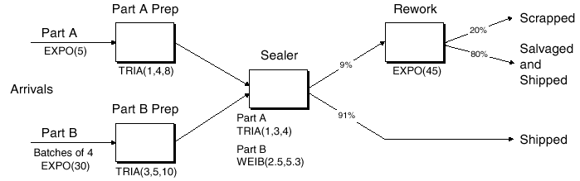

**Bullet points describing key system features:**

* The system produces two different sealed electronic units (A, B)
* Arriving parts are cast metal cases machined to accept the electronic parts
* Part A, Part B have separate prep areas
* Both unit types go to the Sealer for assembly and testing, and then to Shipping or Rework
* After Rework units are salvaged (and shipped), or scrapped

**Part A Information:**

* Interarrivals: expo (5) minutes
* From arrival point, proceed immediately to Part A Prep area
  + Process = (machine + deburr + clean) ~ tria (1,4,8) minutes
* Go immediately to Sealer
  + Process = (assemble + test) ~ tria (1,3,4) min.
  + 91% pass, go to Shipped; Else go to Rework
* Rework: (re-process + testing) ~ expo (45) min.
  + 80% pass, go to Salvage/Ship; Else go to Scrap

**Part B Information:**

* Interarrivals: *batches* of 4, expo (30) min.
* Upon arrival, batch separates into 4 individual parts
* From arrival point, proceed immediately to Part B Prep area
  + Process = (machine + deburr +clean) ~ tria (3,5,10)
* Go to Sealer
  + Process = (assemble + test) ~ weib (2.5, 5.3) min. , *different* from Part A, though at same station
  + 91% pass, go to Shipped; Else go to Rework
* Rework: (re-process + test) = expo (45) min.
  + 80% pass, go to Salvage/Ship; Else go to Scrap

**Model Run Data and Output**

* Start empty & idle, run for four 8-hour shifts (1,920 minutes)
* Collect statistics for each work area on
  + Resource utilization
  + Number in queue
  + Time in queue
* For each exit point (Shipped, Salvage/Shipped, Scrap), collect total time in system (a.k.a. cycle time)

1. **Additional Modeling Features**

The lab instructor will guide you through using two additional modeling features:

* Schedules
* Resource failures and repairs

Powerpoint slides will be used.

1. **Lab Assignment**
2. Run the Electronics Assembly Model for a single replication with no warm-up for 160 hours or 20 8 hour days. What appears to be a problem area and why?
3. The original model is shown to the production manager. It is pointed out that the simulation is only of the first shift of a two-shift day. On the second shift there are two operators at Rework. The system runs 16-hour per day. It is also pointed out that the Sealer fails sometimes with the following characteristics:

* Uptimes ~ exponential, mean 2 hours
* Repair times ~ exponential, mean 4 minutes

Complete modifications to the Electronics Assembly Model to create the Enhanced Electronics Assembly Model that incorporates the features pointed out by the production manager. Run a single replication with no warm-up for 160 hours or 10 16 hour days. Set the base time units to minutes. Is the problem identified in (1) still present?

1. E-mail the Enhanced Electronics Assembly Model Arena file (*.doe file) with your names in the program model window to the instructor. Also add text to the model window that answers the questions asked in 1 and 2.